AAC Inclusion Study Survey
Consent Form
1. EXPLANATION OF THE RESEARCH and WHAT YOU WILL DO:
You are being asked to participate in a research study to learn about the experiences of
educational team members who support students who use augmentative and alternative
communication (AAC)* in general educational settings (students who use AAC and are being
provided with education in their grade level classroom with same aged peers).
*For the purposes of this study AAC is defined as any method of communication other than speech including (a) methods that rely solely on the individual’s body and abilities (for example: sign language, gestures) and (b) methods that rely on other supports (for example: communication apps on mobile devices, voice output communication systems,
low tech communication boards with pictures and/or words). AAC can be used by an individual when speech is limited or absent.
As part of the study you will be asked to complete the following activities:
- An online written survey (approximately 20 minutes)
- An optional telephone interview (approximately 20 minutes)

To participate in this research project, you must be at least 18 years old and work as a Speech
Language Pathologist, educator, or paraeducator/paraprofessional/instructional assistant/aide and support a student who uses AAC in a general education setting.
2. YOUR RIGHTS TO PARTICIPATE, SAY NO, OR WITHDRAW:
Participation in this research project is completely voluntary. You have the right to say no. You
may change your mind at any time and withdraw. You may choose not to answer specific
questions or to stop participating at any time.
3. COSTS AND COMPENSATION FOR BEING IN THE STUDY:
Participants in this research study will have the option to enter a drawing for one of eight $25 gift cards (drawings are scheduled to occur on June 1st, and 2nd, 2021).
4. CONTACT INFORMATION FOR QUESTIONS AND CONCERNS:
If you have concerns or questions about this study, such as scientific issues, or how to do any part of it, please contact the researcher.
5. DOCUMENTATION OF INFORMED CONSENT:
By clicking on the button below, you indicate your voluntary agreement to participate in this online survey.

Are you a general education teacher, special education teacher, paraeducator/paraprofessional/ teacher assistant/aide, or speech language pathologist who currently works on an educational team that supports a student with a disability who uses AAC in a general education setting?
- Yes
- No

In this section you will answer questions about yourself, your education level, and work experiences.

Please select your current role as an educational team member.
- Speech language pathologist
- Special education teacher
- General education teacher
- Paraeducator/paraprofessional/instructional assistant/aide, etc.

Please select the type of school in which you work. Check all that apply.
- Preschool
- Elementary
- Middle school
- High school
- Charter
- Private
- Other (please specify): _______________________

Please select the grade level(s) in which you work. Check all that apply:
- PreK
- K
- 1
- 2
- 3
- 4
- 5
- 6
- 7
- 8
- 9
- 10
- 11
- 12

Which of the following best describes your current employer?
- Employed by a school district
- Employed by an intermediate school district/regional educational service agency
- Employed by a charter school
- Employed by the state
- Employed by a private school
- Other (please specify):________________________________________________

Which of the following best describes your current employment status?
- I work less than 20 hours a week
- I work 20-29 hours a week
- I work 30+ hours a week

Please select the IEP categories under which you serve students. Check all that apply.
- Autism
- Deaf-blindness
- Deafness
- Developmental delay
- Emotional disturbance
- Hearing impairment
- Intellectual disability
- Multiple disabilities
- Orthopedic impairment
- Other health impairment
- Specific learning disability
- Speech or language impairment
- Traumatic brain injury
- Visual impairment (including blindness)
Student with disability, not otherwise specified

Please indicate the number of students with disabilities (those with IEPs) you currently support:
________________________________________________________________

Please indicate the length of time in your profession regardless of the environment.
- Years ________________________________________________
- Months ________________________________________________

Please indicate the length of time (months/years) in your current position.
- Years ________________________________________________
- Months ________________________________________________

What is your highest degree?
- High School/GED
- Associate's Degree
- Bachelor's Degree
- Master's Degree
- Doctorate Degree

What is the major or concentration of your highest degree?
________________________________________________________________

Please indicate any professional certificate/credential(s) you currently have:
________________________________________________________________

In which state do you work?
(drop down of all states and U.S. territories)

How do you identify your gender?
- Male
- Female
- Other (please specify): ________________________________________________
- Prefer not to disclose

Please list your age.
________________________________________________________________

What is your race/ethnicity? Select all that apply
- White
- Black, African American
- Hispanic, Latinx, or Spanish origin
- American Indian, Alaska Native
- Native Hawaiian or other Pacific Islander
- Asian
- Some other race or origin (please specify): __________________________________

Is English your first language?
- Yes
- No

(If no is selected on the previous question)
What is your first language?

For the next question we define AAC in the following ways:

No tech unaided AAC
For example: sign language, gestures, facial expressions, vocal approximations
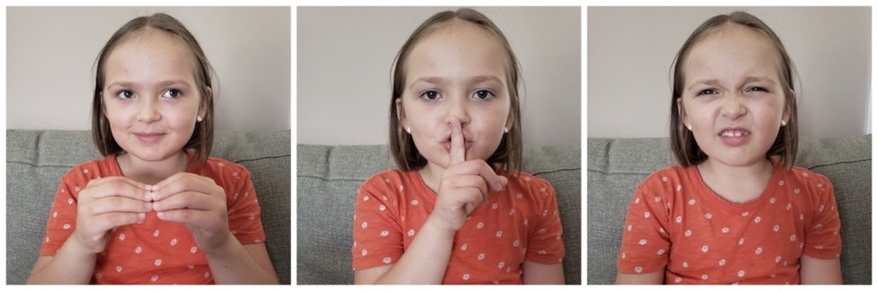

Low tech aided AAC - paper/object based
For example: PECS, core boards, photo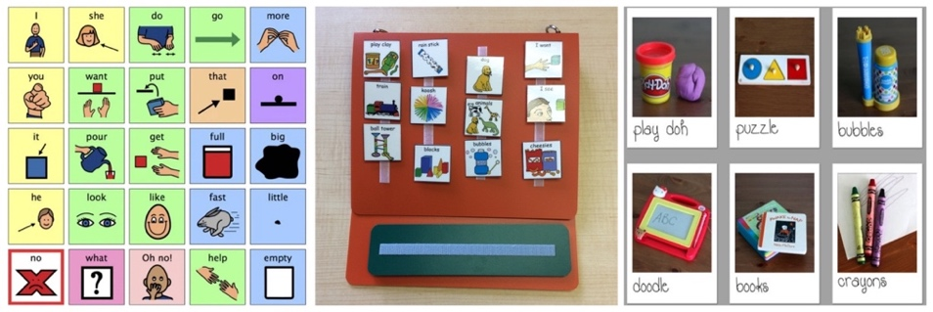
Mid-tech aided AAC - recorded speech with static display
For example: Paper overlays that must be changed manually. The display that does not change when an icon is selected.


High-tech aided AAC - voice output with dynamic display
For example: Computerized display that changes when an icon is selected.
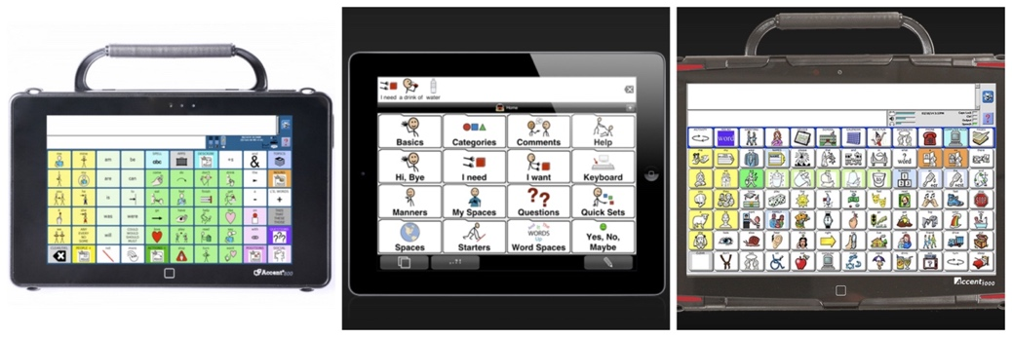
Using the matrix below, please indicate how many students you currently support who use AAC and how many of these students are included in a general education classroom for at least part of the school day. *Use the definitions above for system type
 | Number of students using this type of AAC system | Number of students using this type of AAC system in general education setting
No Tech
Low Tech
Mid-Tech
High Tech
Combination of systems

For each of the activities below, please indicate approximately how much time you spend in each of the following activities?
Approximately how much time do you spend in this activity? For example: daily, weekly, monthly, quarterly, annually, never.
Collecting data about AAC for students
Developing individualized support for students who use AAC
Providing individualized support for students who use AAC
Collaborating, planning, and/or meeting with other team members regarding students who use AAC
Managing AAC equipment (for example: trouble shooting, programming, charging AAC
Other AAC activity: please specify what activity in the space below
Other AAC activity: please specify what activity in the space below

How have you acquired knowledge about AAC? Please rank order the following sources by placing them in order with the source that has provided you with the most information on top (1), second most information next (2), third most information (3), etc.
______ Articles from professional journals (1)
______ Downloadable research and practice briefs (2)
______ Online resources/websites (3)
______ Webinars (4)
______ Social media (for example: twitter, Facebook, blogs, instagram, Pinterest) (5)
______ AAC networks (6)
______ Committee or task force involvement (7)
______ In-district workshops/professional development trainings (8)
______ Out-of-district workshops/professional development trainings (9)
______ 1-to-1 coaching or mentoring (10)
______ Summer institutes (multi-day) (11)
______ State or national conference (12)
______ Other, Please describe: (13)

How have you acquired knowledge about supporting the inclusion of students with IEPs in general education classrooms? Please rank order the following sources by placing them in order with the source that has provided you with the most information on top (1), second most information next (2), third most information (3), etc.
______ Articles from professional journals (1)
______ Downloadable research and practice briefs (2)
______ Online resources/websites (3)
______ Webinars (4)
______ Social media (for example: twitter, Facebook, blogs, instagram, Pinterest) (5)
______ AAC networks (6)
______ Committee or task force involvement (7)
______ In-district workshops/professional development trainings (8)
______ Out-of-district workshops/professional development training (9)
______ 1-to-1 coaching or mentoring (10)
______ Summer institutes (multi day) (11)
______ State or national conferences (12)
______ Other, please describe: (13)

In what areas do you feel the most confident or skilled to support the inclusion of students who use AAC in general education classrooms? Please rank order the topics by placing them in order with the area in which you feel most confident/skilled first (1), second area in which you feel most confident/skilled (2), third area you feel most confident/skilled (3), etc.
______ AAC programming (1)
______ Adapting curriculum (2)
______ Adapting materials (3)
______ Collaboration/Communication/Team Relationships (4)
______ Peer-mediated supports (5)
______ Utilizing paraeducator/paraprofessional/instructional assistant/aide to support the inclusion of students who use AAC (6)
______ Other (please indicate): (7)

In what areas do you feel you need additional education to support the inclusion of students who use AAC in general education classrooms? Please rank order the topics by placing them in order with the area in which you feel most important/urgent (1), second most important/urgent (2), third most important/urgent (3), etc.
______ AAC programming (1)
______ Adapting curriculum (2)
______ Adapting materials (3)
______ Collaboration/Communication/ Team Relationships (4)
______ Peer-mediated supports (5)
______ Utilizing paraeducator/paraprofessional/instructional assistant/ aide to support the inclusion of students who use AAC (6)
______ Other (please indicate): (7)

What resources do you currently have that support the inclusion of students who use AAC in general education classrooms? Please rank order the support by placing them in order by the support that is of greatest importance (1), second most important (2), third most important (3), etc.
______ Access to appropriate curricula/materials (1)
______ Access to relevant professional development/training opportunities (2)
______ Adequate classroom space (3)
______ Administrative support (4)
______ Appropriate class size (5)
______ Collaboration with the educational team (6)
______ Dedicated time to plan for AAC supports (7)
______ Other (please indicate): (8)

Please note your level of agreement with each of the following statements below.
(Scale: 1-Strongly Agree; 2-Agree; 3-Neither agree nor disagree; 4-Disagree; 5-Strongly Disagree)
- Implementing inclusion saves time and money
- Inclusion benefits students who use AAC
- Inclusion requires too much planning
- Training around inclusion is important for students who use AAC
- Inclusion detracts from instructional time
- Inclusion benefits all students
- Without inclusionary programs, we are violating students' rights
- Inclusion is just a passing fad
- Inclusion cannot be effective without administrative support
- Schools do not have the resources necessary to implement inclusive programs

What benefits have you seen from the inclusion of students who use AAC in general education settings?
________________________________________________________________

What challenges have you faced including students who use AAC in general education settings?
________________________________________________________________

What recommendations do you have to improve the inclusion of students who use AAC in general education settings?
________________________________________________________________

Thank you for your response. Please list other individuals who support students who use AAC in inclusive PreK-Grade 12 settings. Please list names and emails

