**Supplementary Appendix S5**

**Generated Theme: Burning Out—Surviving**

**Excerpt from Step 1: Assessing Beliefs, from Meeting Notes Focused on Expectations:**

|  |
| --- |
| We did not originally generate an expectation for burning out as a process in which many SETs view themselves as surviving, we conceived of and settled on this theme during memoing—*specifically during Step 3*. However, it is similar to our expected theme of emotional exhaustion, where we anticipated that participants would note being overwhelmed by the sheer amount of work responsibilities and student needs. This experience of being overwhelmed would manifest as emotional and physical exhaustion and sometimes as brain fog or struggling to think straight. |

**Excerpt from Step 2: Building New Beliefs Through Encounters with the Data, from Initial Memoing on Focus Groups:**

|  |
| --- |
| **Which pre-coding expectations are being supported/expanded?**  N/A for this theme, as it was not a pre-coding expectation  **Which pre-coding expectations are mixed or inconsistent?**  N/A for this theme  **What new information/ideas/perspectives relevant to burnout conceptualization or causes is arising from the data?**  Lack of time to get everything done; feeling like you can’t keep up or get everything done is chronic  Supporting another SET who cries every week—trying to help them survive.  **Which pre-coding expectations are absent/not reinforced?**  N/A for this theme  **Overall Takeaways from the Transcript**  SETs being catch-alls for extra duties, subbing, having to teach gen ed class when geded teacher leaves, so the SET can no longer push in/co-teach with a focus on the SWDs. Generally the lack of continuity in structure/expectations for day-to-day and week to week for inclusion/resource teachers. |

**Excerpt from Step 3: Listing Preliminary Themes, from Focused Memos of Preliminary Themes**

|  |
| --- |
| One teacher summarized burnout as a state of survival, using the metaphor of being stuck on a hamster wheel […]. Several other teachers echoed these sentiments, highlighting the feeling of drowing or not being able to fully accomplish the tasks to which they were assigned. Another teacher described their job as a race in which they were blindfolded with their shoes tied together, meaning that being a special education teacher inevitably feels like ‘you’re going to fall’.  As we analyzed the data, it became clear that the participants provided information extending and surpassing the original expectations, which were conceptualized as emotions. In their descriptions of burnout, the participants ultimately discussed burnout more as a two-pronged continuum/path of states [later we agreed stages was a more accurate term] that teachers experienced. On one side of the continuum is doing well/not burned out. On the other is gone, already left the profession. The next [stages] after doing well/not burned out were two distinct states of burnout: (a) struggling to cope with the emotional load and (b) surviving/triaging to attempt to keep up with the workload.  Is it a hamster wheel? Or is it survival? It’s more survival, it seems like the participants are constantly playing three card monte trying to provide students’ services with the limited resources they have.  Although there are often persistent emotional feelings [e.g., depersonalization, frustration], SETs end up in one of two main states: survival or checked out [we updated “checked out” to “being done”]. While actions can occur just based on emotions, they are more used by participants as indicative of a [stage]. |

**Excerpt from Step 4: Evaluating Themes Through Coding, from the Final Codebook**

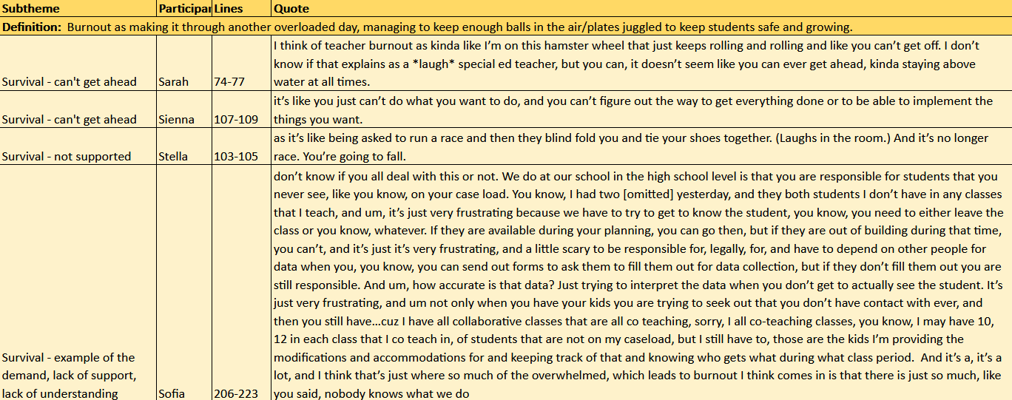

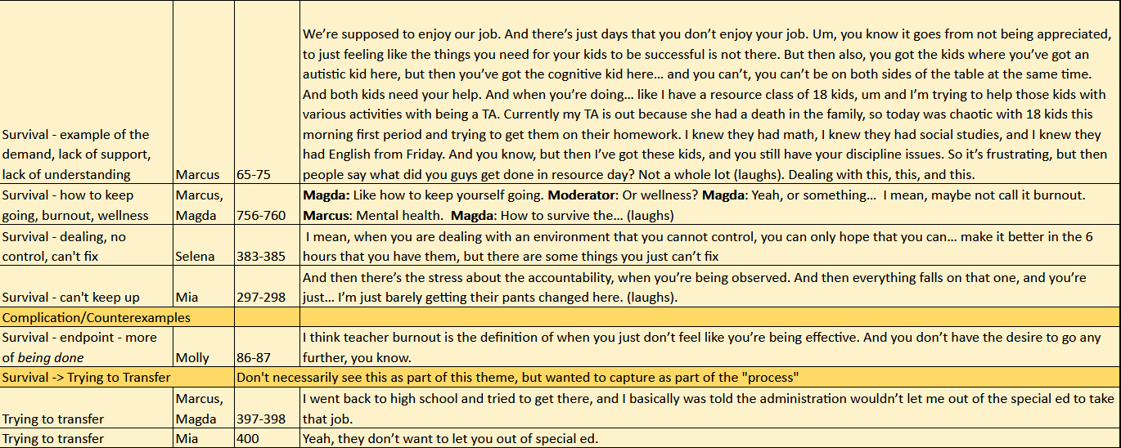

In our discussion finalizing survival, we determined that the complication/counter-example was less about surviving and more about losing the feeling of personal accomplishment as part of *being done.*